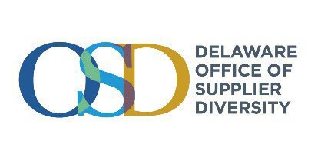

State of Delaware Procurement Resources

To become more connected with the State of Delaware for access to opportunities for networking, business development, and contracting you are invited to consider the following:
State of Delaware Procurement Site: Your guide to the state’s procurement practices, please visit https://mymarketplace.delaware.gov/.
Vendor Learning Center: Learn “How to Do Business with The State of Delaware”: Government Support Services (GSS) Contracting Unit offers free training sessions to educate vendors on how to do business with the State of Delaware. This training covers the above as well as categories of procurement, spending thresholds, transparent business intelligence, access to opportunity points, the state’s checkbook and Procurement card spend sites, and more; all to help you determine if you might wish to bid on future contacts. Unadvertised below-threshold opportunities are also explained. Visit: https://mymarketplace.delaware.gov/vendors/ procurement-education.shtml.
Register for Formal Contracting Opportunity Notifications & Search Open Solicitations: Search current bid opportunities at http://bids.delaware.gov. Register for a free service that allows you to receive bid notifications for your industry; sign up at https://denotificationservices.portal.finalsiteconnect.com/.
Complete Supplier Registration on the eSupplier Portal: The State does not accept IRS Form W-9, instead all suppliers are required to register through the eSupplier Portal. Detailed instructions for submitting new registrations, obtaining user IDs and passwords, and submitting change requests are located on the FAQs / Contact Us page of the eSupplier Portal at https://esupplier.erp.delaware.gov/.
Search for Delaware Contracts: You can search current and archived contracts at http://contracts.delaware.gov/. This site includes information on pricing for central contracts, expiration dates, originating solicitations, Awarded Vendors, which businesses submitted proposals, and historical spend reporting for GSS central contracts. These contracts are for formal procurement activities and the information available may vary based upon the agency initiating the solicitation and controlling the contract.
Seek New Opportunities to Do Business with Schools, Fire Departments, and Municipalities: Not all entities are required by Delaware Code to utilize State contracts, but they may choose to or may contract on their own. Excluded entities are schools, fire departments, and municipalities. Therefore, you are eligible to market directly to these groups. To help you identify whom to contact GSS maintains a list of those procurement officers at: https://mymarketplace.delaware.gov/vendors/bids-poli-subs.shtml

Office of Supplier Diversity Certification: Review the OSD certification policy & eligibility requirements; and apply for certification as a Diverse Business and/or Small Business at https://business.delaware.gov/osd/

Inclusion of the entire community of traditional, diverse, and small businesses is how we ALL work together. | Office of Supplier Diversity 820 N. French Street, 10th Fl. Wilmington, Delaware 19801 https://de.gov/osd
Updated February 2026

